Saint Joseph School Birthday Book Form
Thank you for supporting the love of reading!

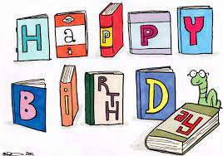

Your Name: ___________________________________________________________________________

Street Address: ________________________________________________________________________

Student Name: ________________________________________________________________________

Student Homeroom: ______________ Student Date of Birth: _________________________________

I prefer my student _______________________ or the librarian ___________________ pick the book.

Number of books at $20 per book__________ Amount enclosed $______________________________
(Cash or check payable to St. Joseph School Library)
_______Yes! I am interested in a corporate match for my donation, please contact me.
_____________________________________________________________________________________
For office use:
Check# ____________ Date: _____________________________________________________________
Book Chosen: _________________________________________________________________________

